**TRIBHUVAN UNIVERSITY**

**INSTITUTE OF MEDICINE**

**POKHARA NURSING CAMPUS**

**RAMGHAT-12, POKHARA**



**LESSON PLAN ON**

**PNEUMONIA AND PULMONARY EMBOLISM**

|  |  |
| --- | --- |
| **Submitted To** | **Submitted By** |
| Respected Madam | Babita Shah |
| Shrijana Poudel | Roll No:- 05 |
| Lecturer | BNS 2nd Year |
| TU IOM | Pokhara Nursing Campus |
| Pokhara Nursing Campus | 17th Batch |

|  |
| --- |
| Subject : Geriatric Nursing  Topic : Pneumonia And Pulmonary Embolism  Unit : 4  Date : 2080/10/  Level of learner student : BNS 1st Year  Time :  Duration : 1 hour  No. of learners : 36  Venue : Pokhara Nursing Campus (BNS 1st Year class room)  Name of supervisor : Respected Madam Shrijana Poudel  Educational methods : Interactive lecture  Learning resources : Power-point, poster, whiteboard |

**General Objectives:**

At the end of the classroom session, BNS 1st year students will be able to explain about the pneumonia and pulmonary embolism.

**Lesson plan:**

|  |  |  |  |  |  |  |
| --- | --- | --- | --- | --- | --- | --- |
| **SN** | **Specific objective** | **Content** | **Time** | **T/L methods** | **T/L media** | **Evaluation** |
|  | At the end of this session BNS 1st year students will be able to: | -Greeting  -Attendance  -Review  -Introduction   * Topic   -Objectives  -Pre-test | 3mins | Brainstorming | Power point (picture) |  |
| 1) | define pneumonia | Definition of Pneumonia | 2mins | Interactive lecture | Power point | What is pneumonia? |
| 2) | classify pneumonia | Classification of pneumonia | 2mins | Interactive lecture | Power point | Classify Pneumonia. |
| 3) | list the causes of pneumonia | Causes of pneumonia | 3mins | Interactive lecture | Power point and white board | What are the causes of pneumonia? |
| 4) | list the signs and symptoms of pneumonia | Signs and symptoms of pneumonia | 5mins | Interactive lecture | Poster | What are the signs and symptoms of pneumonia? |
| 5) | state the diagnostic evaluation of pneumonia | Diagnosis of pneumonia |  | Interactive lecture | Power point | State the diagnostic evaluation of pneumonia. |
| 6) | enlist the complications of pneumonia | Complication of Pneumonia | 3mins | Interactive lecture | Power point | State the complication of pneumonia? |
| 7) | enlist the preventive measures of pneumonia | Preventive measures of pneumonia | 5mins | Interactive lecture | Power point | What are the preventive measures of pneumonia? |
| 8) | explain the managements of pneumonia | Managements of pneumonia | 5mins | Interactive lecture | Power point | What are the managements of pneumonia? |
| 9) | define pulmonary embolism | Definition of Pulmonary Embolism | 2mins | Interactive lecture | Power point | What is pulmonary embolism? |
| 10) | list the causes and risk factors of pulmonary embolism | Causes and risk factors of pulmonary embolism | 3mins | Interactive lecture | Poster | What are the causes and risk factors of pulmonary embolism? |
| 11) | list the sign and symptoms of pulmonary embolism | Signs and symptoms of pulmonary embolism | 3mins | Interactive lecture | Power point | What are the signs and symptoms of pulmonary embolism? |
| 12) | state the diagnostic evaluation of pulmonary embolism | Diagnostic evaluation of pulmonary embolism | 3mins | Interactive lecture | Power point | State the diagnostic evaluation of pulmonary embolism? |
| 13) | enlist the complications of pulmonary embolism | Complication of pulmonary embolism | 2mins | Interactive lecture | Power point | State the complications of pulmonary embolism? |
| 14) | enlist the preventive measures of pulmonary embolism | Preventive measures of pulmonary embolism | 3mins | Interactive lecture | Power point | What are the preventive measures of pulmonary embolism? |
| 15) | explain the managements of pulmonary embolism | Managements of the pulmonary embolism | 5mins | Interactive lecture | Power point | What are the managements of pulmonary embolism? |
| 16) |  | -post test  -summary  -home assignment  -plan for next class  -references | 3mins | Questioning and answering |  |  |

**PNEUMONIA**

**INTRODUCTION**

Pneumonia is **a form of acute respiratory infection that affects the lungs**. The lungs are made up of small sacs called alveoli, which fill with air when a healthy person breathes. When an individual has pneumonia, the alveoli are filled with pus and fluid, which makes breathing painful and limits oxygen intake.

**CLASSIFICATION**

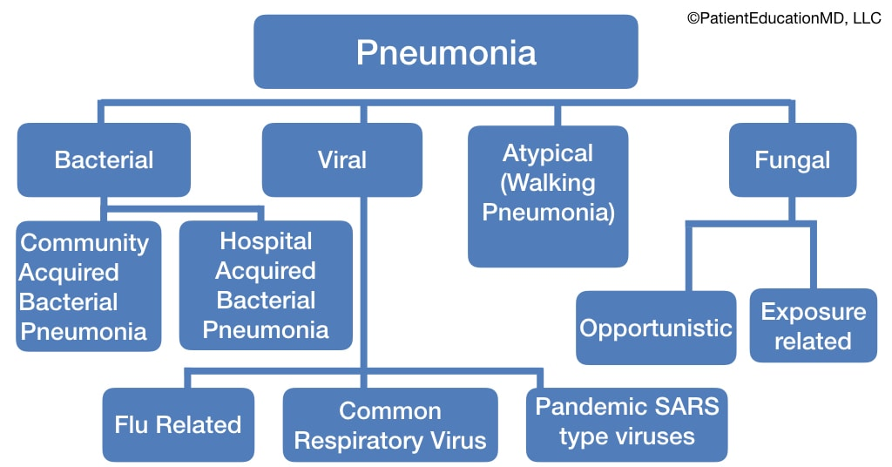

**RISK FACTORS**

* History of smoking and exposure to certain chemicals.
* Advanced age and upper respiratory tract infections.
* Prolonged immobility and surgery
* Swallowing disorders

**SYMPTOMS**

* Coughing
* Breathing difficulties
* Pain in the chest
* Cold sores
* Confusion ,urinary or faecal incontinence **(in elderly)**

**DIAGNOSIS/ INVESTIGATION**

* History taking and physical examination.
* Sputum gram smear and culture and sensitivity test.
* Complete blood count.
* Chest X-ray and Bronchoscopy.
* Additional test: skin test for tuberculosis, blood and urine culture, ABG analysis.

**COMPLICATION**

* Septicaemia
* Lung abscess
* ARDS
* Para-pneumonic Effusion
* Hypotension
* Empyema
* Respiratory/Renal failure

**PREVENTION**

* Vaccination
* Hand Washing
* Dental Hygiene
* Good Health Habits

**MANAGEMENTS**

**MEDICINE**

1. **Antibiotics**

* *Mild to moderate cases:*
* Fluoroquinolone(levofloxacin, Moxifloxacin )
* Amoxicillin-clavulanate and Azithromycin
* Cephalosporin
* Ceftriaxone
* *Severe cases:*
* Cefepime or ceftazidime
* Imipenem or meropenem
* Piperacillin-tazobactam
* Levofloxacin
* Ciprofloxacin
* Aminoglycoside
* Vancomycin
* Linezolid

1. **Antiviral Medications**
2. **Fever Reducers**
3. **Cough Medicine**

**Assessment:**

**-** Shortness of breath( dyspnea)

- Chest pain

-Tachycardia

- Cough with sputum

**NURSING INTERVENTION**

1. Improve Airway Patent:
   * Proper positioning (propped up)
   * Chest physiotherapy: postural drainage
   * Humidification of air/oxygen
   * Deep breathing and coughing to remove secretion
2. Promote fluid intake:

* Increased fluid intake to compensate fever, tachypnea and to liquefy secretion.
* Provide adequate warm nutritious fluid frequently.

1. Maintain nutritional need:

* Decreased appetite due to shortness of breath, fatigue, fever.
* Provide adequate warm nutritious calories, electrolytes.

1. Monitor and manage potential complications.

* Watch for the resolution of the symptoms or duration of the condition, response to the therapy.
* Monitor the complications such as shock, respiratory failure, pleural effusion, atelactesis and informed to physician if any.
* Nursing intervention to prevent complication.

1. Promote home and community care:

* Teach the patient about proper administration of drugs and management potential side effects of drugs.
* Instruct breathing exercise to clear the lungs and promote full expansion of lungs.
* Encourage gradual increase of activities.
* Instruct to take adequate nutrition, fluids.
* Need of follow up visit.

**PULMONARY EMBOLISM**

**INTRODUCTION**

Pulmonary Embolism is a blockage of an artery in the lungs by a substance that has moved from elsewhere in the body through the bloodstream (embolism).

**CAUSES AND RISK FACTORS**

* Venous stasis
* Hypercoagulable states
* Immobilization
* Surgery & trauma
* Hereditary factors
* Smoking
* Supplemental estrogen
* Overweight

**SIGNS AND SYMPTOMS**

* Shortness of breath
* Chest pain
* Bloody or blood-streaked sputum
* Excessive sweating
* Rapid or irregular heartbeat

**DIAGNOSTIC INVESTIGATION**

1. Blood test: D-dimer test
2. Chest X-ray
3. Ultrasound
4. CT scan & MRI
5. Pulmonary angiogram

**COMPLICATION**

1. Pulmonary hypertension
2. Chronic thrombotic pulmonary embolism

**PREVENTION**

1. Anticoagulants
2. Graduated compression stockings
3. Pneumatic compression
4. Physical activity
5. Drink plenty of fluids

**TREATMENT**

1. **Medications:**

* Blood thinners (anticoagulants)
* Clot dissolvers (thrombolytic)

1. **Surgical and other procedures:**

* Clot removal
* Vein filter

**Assessment:**

* Shortness of breath
* Chest pain and restlessness
* Bloody or blood-streaked sputum

**NURSING MANAGEMENTS**

1. Bed rest with active and passive range of motion.
2. Keep the patient with fowler position to enhance ventilation.
3. Assist with turning, coughing, and deep breathing to mobilize secretions and clear airway.
4. Assess respiratory status to detect respiratory distress.
5. Assess cardiovascular status. An irregular pulse may signal arrhythmia caused by hypoxemia.
6. If cause of PE by thrombophlebitis, temperature may be elevated.
7. Administer O2 to enhance oxygenation.
8. Establish an IV line for fluids and drugs.
9. Monitor and record intake and output to detect fluid volume overload and renal perfusion.
10. ABGs monitoring to evaluate the need for mechanical ventilation.
11. Monitor laboratory studies because patient on heparin and need to evaluate electrolyte, CBC and hematocrit.

**SUMMARY**

Pneumonia is a form of acute respiratory infection that affects the lungs where the alveoli are filled with pus and fluid, which makes breathing painful and limits oxygen intake. It includes bacterial, viral, fungal and atypical pneumonia. Risk factors of pneumonia are alcoholism, lungs and heart disease, nursing home residence. Sign and symptoms of pneumonia are coughing, breathing difficulties, pain in the chest, cold sores. Complications of pneumonia are septicaemia, lung abscess, ARDS, para-pneumonic effusion, hypotension, empyema, respiratory/ renal failure. Preventive measures of pneumonia are vaccination, hand washing, good health habits. Pulmonary Embolism (PE) is a blockage of an artery in the lungs by a substance that has moved from elsewhere in the body through the bloodstream (embolism). Venous stasis, Hypercoagulable states, smoking, over weight, surgery and trauma, etc. Are the causes and risk factors of PE. Signs and symptoms of PE are blood-streaked sputum, excessive sweating, rapid or irregular heartbeat, chest pain. Complications of PE are pulmonary hypertension, chronic thrombotic pulmonary embolism. Preventive measures of PE are anticoagulants, graduated compression stockings, drink plenty of fluids, physical activity.

**Test Construction:**

1. Which one of the following is not the sign and symptom of pulmonary embolism?( 1 mark
2. Shortness of breath
3. Chest pain
4. Melena
5. All

2)which one of the following are the complication of pneumonia? ( 1 mark)

1. Septicaemia
2. Lung abscess
3. ARDS
4. All

Which is the preventive measures of pulmonary embolism? (1 mark)

A) Graduated compression stockings

B) Pneumatic compression

C) Both A and B

D) none

**Home Assignment:**

1. Write down the causes of pneumonia and explain its nursing management?
2. Write down the sign and symptoms of pulmonary embolism and explain its nursing management?

**Plan for next class:**

We will discuss about physiological changes in Gastrointestinal tract.

**References:**

Clark, Michael. & Kumar, Parveen. (2009). Clinical medicine (7th Edition)

Gautam, S. (2016). Geriatric Nursing (2nd Edition). Kathmandu: Medhavi Publication.

Hinkle, I.Janice & Cheever, H.Kerry. Text book of Medical-Surgical nursing (13th Edition). New Delhi: Wolters Kluwern PvtLtd

K.C, T. & Rai, B. (2019). A Textbook of Geriatric Nursing (3rd Edition). Kathmandu: Heritage publisher and distributor

Mandal, G.N. (2017). Text book of adult nursing (4th Edition). Kathmandu: Makalu publication house

Subedi, P.S. & Suba, K.H. (2019). A Textbook of Geriatric Nursing (1st Edition). Kathmandu: National Book Center.

Timalsina, R. (2077). Comprehensive Textbook of Geriatric Nursing (3rd Edition). Kathmandu: Samiksha publication.

.